**Implementation**

**5.1 Introduction**

In this chapter we will be discussing the various methods used to develop and implement the projects software artifact. We will analyze the techniques used and discuss any problems encountered as well as any noticeable achievements. An examination of why these came about and in the case of problems, how they were overcome will take place.

The implementation process consisted of two stages; these consisted of the creation of a database system and a user interface. The stages will be discussed to determine why they were and possibly why they were not a complete success. Unfortunately there were a few components which could not be implemented in the time made available and this chapter will outline the reasons for this. Finally, this chapter will outline the ongoing testing which was carried out as part of the implementation process.

**5.2 Database Implementation**

Database implementation was first to be initiated. This was a logical step to providing the back end functions required to be called upon later by the interface.

**5.2.1 Stages of Implementation**

* Hardware and Software Requirements
* The installation and initial set up of the database management system and development environment.
* Implementation of database components
* Testing

*5.2.1.1 Hardware and Software Requirements*

1. The following sections list the minimum hardware and software requirements to install and run SQL Server 2008.
2. For both 32-bit and 64-bit editions of SQL Server 2008, the following apply:
3. SQL Server 2008 Enterprise is available for evaluation during a 180-day trial period. For more information, see the SQL Server: *(*[*http://go.microsoft.com/fwlink/?LinkId=51646*](http://go.microsoft.com/fwlink/?LinkId=51646)*).*
4. Microsoft recommends that you run SQL Server 2008 on computers with the NTFS file format. For upgrades to SQL Server 2008, FAT32 file systems will not be blocked.
5. SQL Server Setup will block installations on read-only or compressed drives.
6. For information about using SQL Server 2008 tools to prepare for an upgrade to SQL Server 2008, see Using Upgrade Advisor to Prepare for Upgrades.
7. SQL Server does not install the .NET Framework 3.5 software development kit (SDK). However, the SDK contains tools that are useful when you use the .NET Framework for SQL Server development.
8. You can download the .NET Framework SDK from the .NET Framework Web site. *(*[*http://go.microsoft.com/fwlink/?LinkID=51069*](http://go.microsoft.com/fwlink/?LinkID=51069)*)*
9. Requirements to restart computers during SQL Server Setup: Installation of the .NET Framework requires a restart of the operating system. If Windows Installer installation also requires a restart,
10. Setup will wait until the .NET Framework and Windows Installer components have installed before restarting.
11. For more information about features of SQL Server 2008, see the following:
    1. Editions and Components of SQL Server 2008
    2. Features Supported by the Editions of SQL Server 2008

The following requirements apply to all SQL Server 2008 installations:

|  |  |
| --- | --- |
| Component | Requirement |
| Framework | SQL Server Setup installs the following software components required by the product:  .NET Framework 3.5  SQL Server Native Client  SQL Server Setup support files |
| Software | SQL Server Setup requires Microsoft Windows Installer 4.5 or a later version, and Microsoft Data Access Components (MDAC) 2.8 SP1 or a later version. You can download MDAC 2.8 SP1 from the [MDAC downloads](http://go.microsoft.com/fwlink/?LinkId=50233) Web site.  After installing required components, SQL Server Setup will verify that the computer where SQL Server 2008 will be installed also meets all the other requirements for a successful installation. For more information, see Check Parameters for the System Configuration Checker. |
| Network Software | Network software requirements for the 64-bit versions of SQL Server 2008 are the same as the requirements for the 32-bit versions.  Supported operating systems have built-in network software. Stand-alone named and default instances support the following network protocols:   * Shared memory * Named Pipes * TCP/IP * VIA   Note   Shared memory and VIA are not supported on failover clusters. |
| Virtualization | SQL Server 2008 is supported in virtual machine environments running on the Hyper-V role in Windows Server 2008 Standard, Enterprise and Data Center editions. The virtual machine must run an operating system supported for the specific SQL Server 2008 edition listed later in this topic.  In addition to resources required by the parent partition, each virtual machine (child partition) must be provided with sufficient processor resources, memory, and disk resources for its SQL Server 2008 instance. Requirements are listed later in this topic.  Within the Hyper-V role on Windows Server 2008, a maximum of four virtual processors can be allocated to virtual machines running Windows Server 2008 32-bit or 64-bit editions. A maximum of 2 virtual processors can be allocated to virtual computers that are running Windows Server 2003 32-bit editions. For virtual computer that host other operating systems, a maximum of one virtual processor can be allocated to virtual computers.  **Notes:** It is recommended that SQL Server 2008 be shut down before shutting down or the virtual machine.  Guest failover clustering (configuring failover clustering in SQL Server 2008) is not supported in a Hyper-V environment.  For more information about the Hyper-V role in Windows Server 2008, see the [Windows Server 2008 Web site](http://go.microsoft.com/fwlink/?LinkId=120290). |
| Internet Software | Microsoft Internet Explorer 6 SP1 or a later version is required for all installations of SQL Server 2008. Internet Explorer 6 SP1 or a later version is required for Microsoft Management Console (MMC), SQL Server Management Studio, Business Intelligence Development Studio, the Report Designer component of Reporting Services, and HTML Help. |
| Hard Disk | Disk space requirements will vary with the SQL Server 2008 components you install. For more information, see [Hard disk space requirements](ms-help://MS.SQLCC.v10/MS.SQLSVR.v10.en/s10sq_GetStart/html/09bcf20b-0a40-4131-907f-b61479d5e4d8.htm#HardDiskSpace) later in this topic. |
| Drive | A CD or DVD drive, as appropriate, is required for installation from disc. |
| Display | SQL Server 2008 graphical tools require VGA or higher resolution: at least 1,024x768 pixel resolution. |
| Other Devices | Pointing device: A Microsoft mouse or compatible pointing device is required. |

1. The following .NET Framework versions are required:

* SQL Server 2008 on Windows Server 2003 (64-bit) IA64 - .NET Framework 2.0 SP1
* All other editions of SQL Server 2008 - .NET Framework 3.5

Installation of .NET Framework requires a restart of the operating system. If Windows Installer installation also requires a restart, Setup will wait until .NET Framework and Windows Installer components have installed before restarting.

1. SQL Server Setup will not install the following required components for SQL Server Express and SQL Server Express with Advanced Services. You must install these components manually before you run SQL Server Setup:

* SQL Server Express - .NET Framework 2.0 SP2 and Windows installer 4.5. On Windows Vista, use .NET Framework 3.5 SP1.
* SQL Server Express with Advanced Services - .NET Framework 3.5 SP1, Windows Installer 4.5, and Windows PowerShell 1.0.

1. As with all virtualization technologies, SQL Server 2008 running in a Windows Server 2008 Hyper-V virtual computer will be slower than on a physical computer with the same physical resources.

*5.2.1.2 Configuration and Installation*

The SQL Server Installation Wizard is Windows Installer-based. It provides a single feature tree for installation of all SQL Server components, so you do not have to install the following components individually:

* Database Engine
* Analysis Services
* Reporting Services
* Integration Services
* Replication
* Management tools
* Connectivity components

**Note:**

For local installations, you must run Setup as an administrator. If you install SQL Server from a remote share, you must use a domain account that has read and execute permissions on the remote share.

**To install SQL Server 2008**

1. Insert the SQL Server installation media. From the root folder, double-click setup.exe. To install from a network share, locate the root folder on the share, and then double-click setup.exe.
2. If the Microsoft .NET Framework version 2.0 installation dialog box appears, select the check box to accept the .NET Framework 2.0 License Agreement. **Click Next**. To quit SQL Server 2008 installation, click Cancel. When installation of .NET Framework 2.0 is complete, click Finish.
3. **Windows Installer 4.5** is also required, and might be installed by the Installation Wizard. If you are prompted to restart your computer, restart it, and then restart SQL Server 2008 **setup.exe**.
4. When the prerequisites are installed, the Installation Wizard will run the SQL Server Installation Center. To create a new installation of SQL Server 2008, click New Installation or Add Features to an Existing Installation.
5. The System Configuration Checker will run a discovery operation on your computer. To continue, click OK. Setup log files have been created for your installation.
6. On the Product Key page, select a radio button to indicate whether you are installing a free edition of SQL Server, or a production version of the product that has a PID key.
7. On the License Terms page, read the license agreement, and then select the check box to accept the licensing terms and conditions.
8. The Installation Wizard will install SQL Server prerequisites if they are not already on the computer. These include the following:

* .NET Framework 2.0
* SQL Server Native Client
* SQL Server Setup Support Files

To install prerequisites, click Install.

1. The System Configuration Checker will verify the system state of your computer before Setup continues.
2. On the Feature Selection page, select the components for your installation. A description for each component group appears in the right-hand pane after you select the feature name. You can select any combination of check boxes. For more information, see Editions and Components of SQL Server 2008.

You can also specify a custom directory for shared components by using the field at the bottom of the Feature Selection page. To change the installation path for shared components, either update the path name in the field at the bottom of the dialog box, or click Browse to navigate to an installation directory. The default installation path is C:\Program Files\Microsoft SQL Server\100\.

1. On the Instance Configuration page, specify whether to install a default instance or a named instance. For more information, see Instance Configuration. To continue, click ‘Next’.

Instance ID suffix — by default, the instance name is used as the Instance ID suffix. This is used to identify installation directories and registry keys for your instance of SQL Server. This is the case for default instances and named instances. For a default instance, the instance name and instance ID suffix would be MSSQLSERVER. To use a non-default instance ID suffix, select the Instance ID suffix check box and provide a value.

**Note:** Typical stand-alone instances of SQL Server 2008, whether default or named instances, do not use a non-default value for the Instance ID suffix check box.

Instance root directory — by default, the instance root directory is C:\Program Files\Microsoft SQL Server\100\. To specify a non-default root directory, use the field provided, or click Browse to locate an installation folder.

All SQL Server service packs and upgrades will apply to every component of an instance of SQL Server.

Detected instances and features — The grid shows instances of SQL Server that are on the computer where Setup is running. If a default instance is already installed on the computer, you must install a named instance of SQL Server 2008.

1. The Disk Space Requirements page calculates the required disk space for the features you specify. It then compares the required space to the available disk space. For more information, see Disk Cost Summary.
2. Work flow for the remainder of this topic depends on the features you have specified for your installation. You might not see all of the pages, depending on your selections.
3. On the Server Configuration — Service Accounts page, specify login accounts for SQL Server services. The actual services that are configured on this page depend on the features you selected to install.

You can assign the same login account to all SQL Server services, or you can configure each service account individually. You can also specify whether services start automatically, are started manually, or are disabled. Microsoft recommends that you configure service accounts individually to provide least privileges for each service, where SQL Server services are granted the minimum permissions they need to complete their tasks. For more information, see SQL Server Configuration - Service Accounts and Setting Up Windows Service Accounts.

To specify the same logon account for all service accounts in this instance of SQL Server, provide credentials in the fields at the bottom of the page.

Security Note Do not use a blank password. Use a strong password.

When you are finished specifying login information for SQL Server services, click next.

1. Use the Server Configuration — Collation tab to specify non-default collations for the Database Engine and Analysis Services. For more information, see SQL Server Configuration - Collation.
2. Use the Database Engine Configuration - Account Provisioning page to specify the following:

Security Mode — selects Windows Authentication or Mixed Mode Authentication for your instance of SQL Server. If you select Mixed Mode Authentication, you must provide a strong password for the built-in SQL Server system administrator account.

After a device establishes a successful connection to SQL Server, the security mechanism is the same for both Windows Authentication and Mixed Mode. For more information, see Database Engine Configuration - Account Provisioning.

SQL Server Administrators — you must specify at least one system administrator for the instance of SQL Server. To add the account under which SQL Server Setup is running, click Add Current User. To add or remove accounts from the list of system administrators, click Add or Remove, and then edit the list of users, groups, or computers that will have administrator privileges for the instance of SQL Server. For more information, see Database Engine Configuration - Account Provisioning.

When you are finished editing the list, click OK. Verify the list of administrators in the configuration dialog box. When the list is complete, click next.

1. Use the Database Engine Configuration - Data Directories page to specify non-default installation directories. To install to default directories, click next.

**Important:** If you specify non-default installation directories, ensure that the installation folders are unique to this instance of SQL Server. None of the directories in this dialog box should be shared with directories from other instances of SQL Server.

Use the Database Engine Configuration - FILESTREAM page to enable FILESTREAM for your instance of SQL Server. For more information, see Database Engine Configuration - Filestream.

1. Use the Analysis Services Configuration — Account Provisioning page to specify users or accounts that will have administrator permissions for Analysis Services. You must specify at least one system administrator for Analysis Services. To add the account under which SQL Server Setup is running, click Add Current User. To add or remove accounts from the list of system administrators, click Add or Remove, and then edit the list of users, groups, or computers that will have administrator privileges for Analysis Services.

When you are finished editing the list, click OK. Verify the list of administrators in the configuration dialog box. When the list is complete, click Next.

1. Use the Analysis Services Configuration — Data Directories page to specify non-default installation directories. To install to default directories, click next.

**Important:** If you specify non-default installation directories, ensure that the installation folders are unique to this instance of SQL Server. None of the directories in this dialog box should be shared with directories from other instances of SQL Server.

1. Use the Reporting Services Configuration page to specify the type of Reporting Services installation to create. Options include the following:

* Native mode default configuration
* SharePoint mode default configuration
* Un configured Reporting Services installation

1. On the Error and Usage Reporting page, specify the information you would like to send to Microsoft that will help to improve SQL Server. By default, options for error reporting and feature usage are enabled. For more information, see Error and Usage Report Settings.
2. The System Configuration Checker will run one more set of rules to validate your computer configuration with the SQL Server features you have specified.
3. The Ready to install page shows a tree view of installation options that were specified during Setup. To continue, click Install.
4. During installation, the Installation Progress page provides status so you can monitor installation progress as Setup proceeds.
5. After installation, the complete page provides a link to the summary log file for the installation and other important notes. To complete the SQL Server installation process, click Close.
6. If you are instructed to restart the computer, do so now. It is important to read the message from the Installation Wizard when you are done with Setup.
7. Once you are done with the installation, go to the start button of your computer and click on it it will display or popup a menu as displayed below.

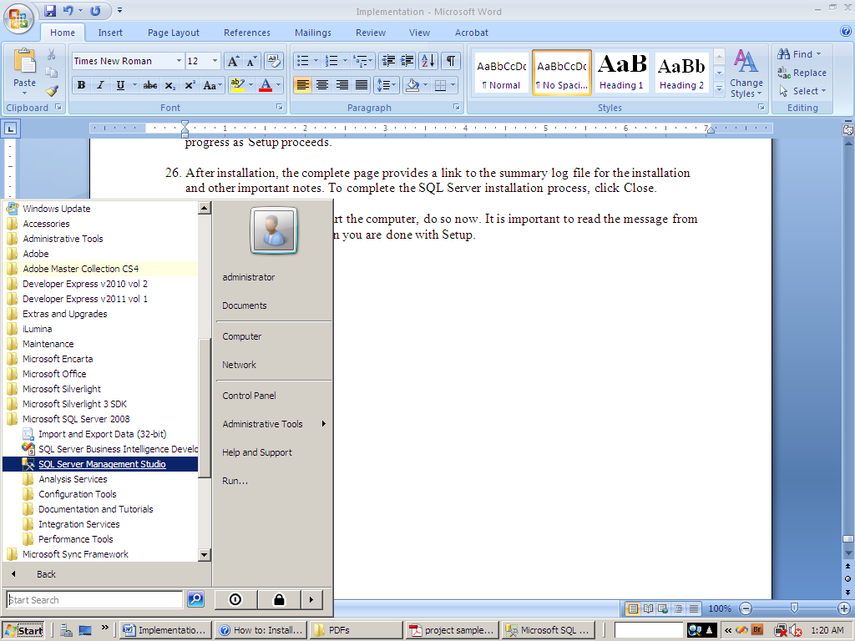

1. Click on all programs and then locate the Microsoft SQL Server 2008 Folder click on it. It will reveal the content of the folder as displayed above.
2. Then click on the SQL Server Management Studio to launch the MS SQL Server 2008 application as shown below. Enter the necessary credentials to login into the MSSQL Server.

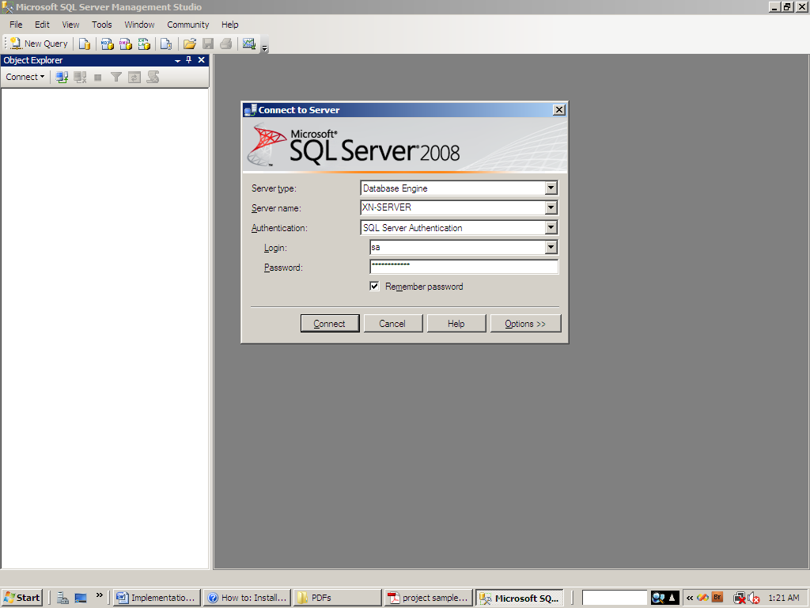

1. If successfully login, the application screen would be displayed as shown below. Then click on the highlighted **New Query** to launch an empty white window

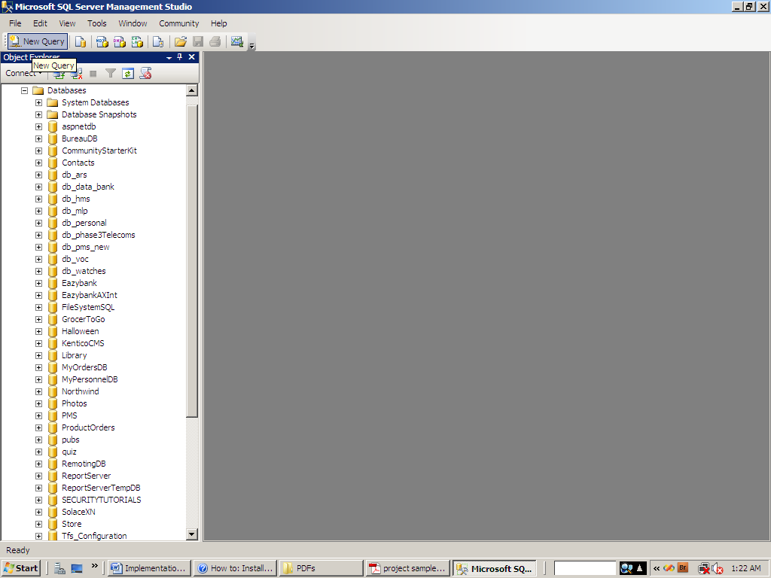

1. Once an empty white window is open, click on File select Open and then click on the File as shown below to launch a dialog box that would enabled you browse for the UniversityDB.sql Script File.

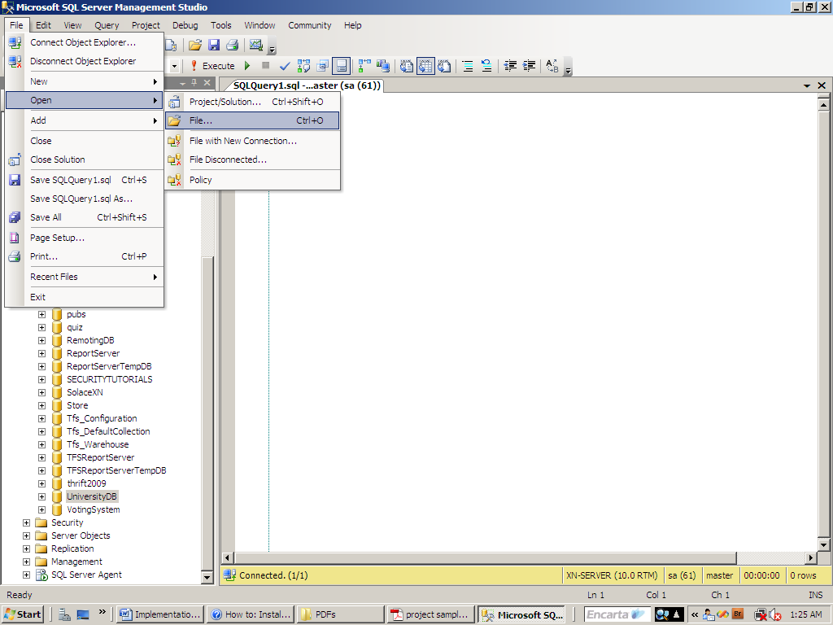

1. Browse to the location where the UniversityDB.sql Script is and click on it to open it as shown below

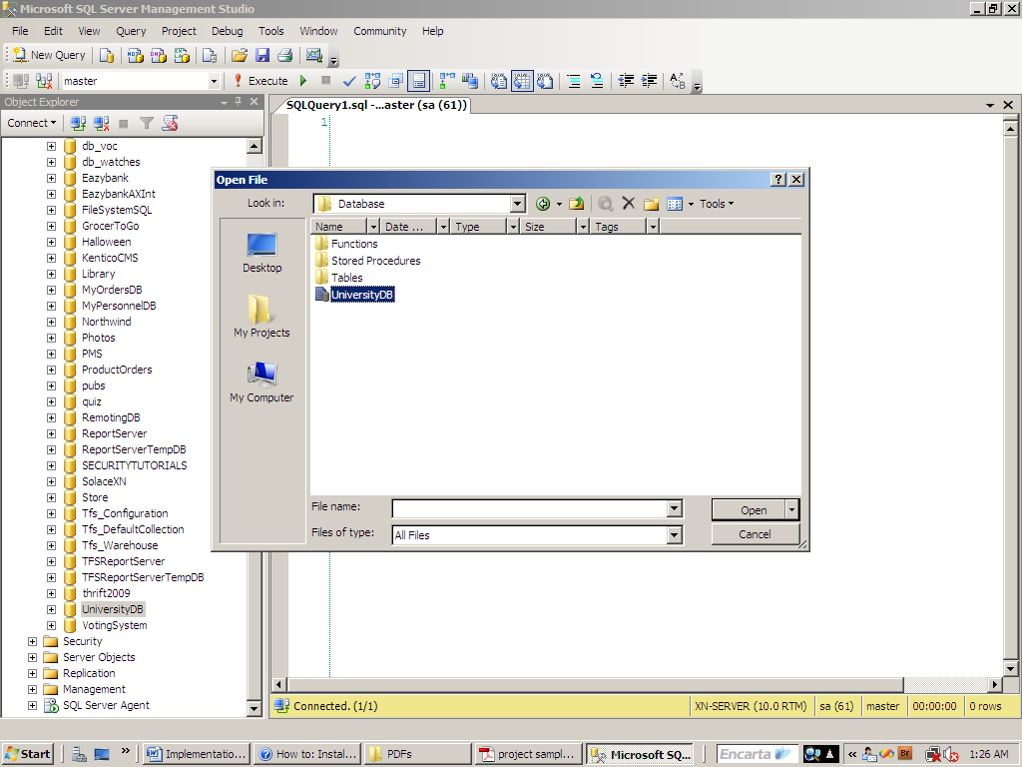

1. Once it is open you will have a screen as displayed below

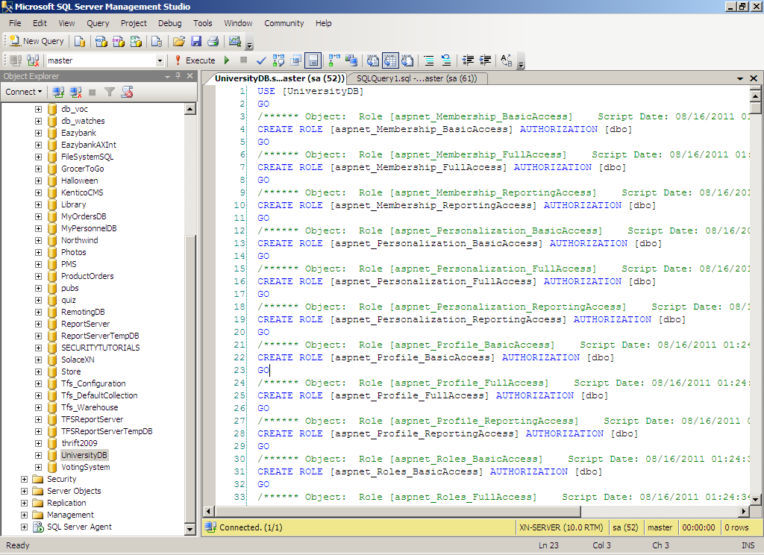

1. **Note:** Type CREATE DATABASE [UniversityDB] then press f5 or click on the execute button to create the database that the scripts can be run on.
2. Click on the highlighted Execute button to run the script to create all the database objects i.e. schemas, tables, database roles, stored procedures, functions etc.

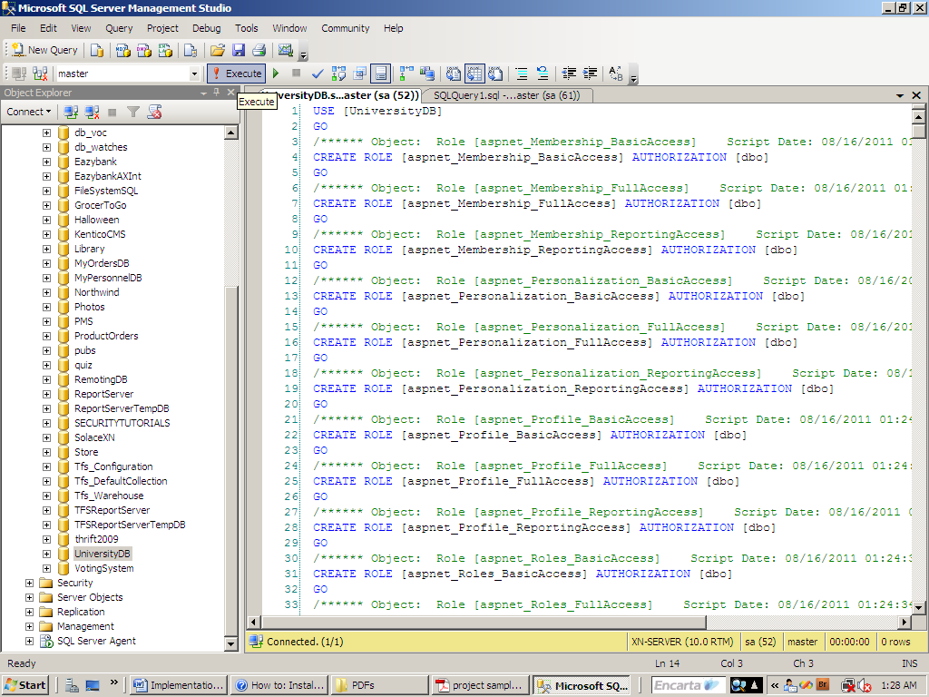

1. Once the creation of the database and all its objects are successful, you will see it been displayed by the left hand side in the server explorer as shown below.

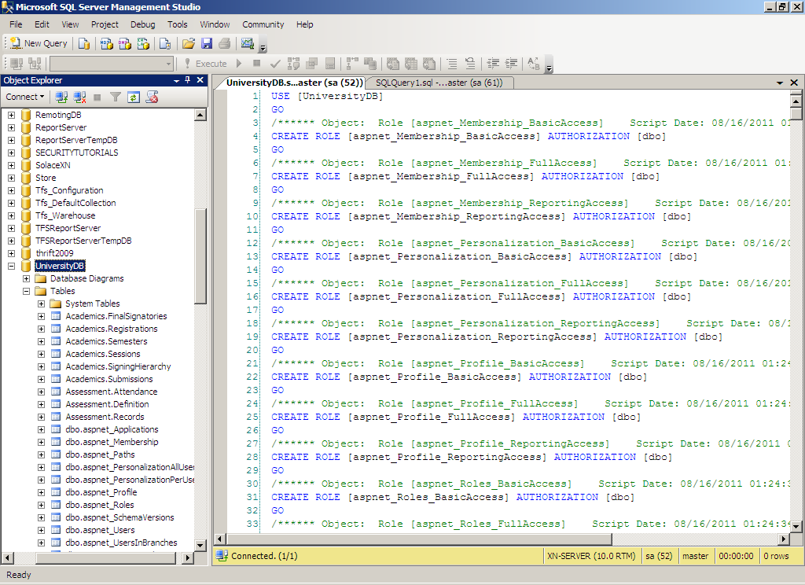

1. Finally go to the web.config file of the project and change the data sources to the name of the machine that’s currently running the SQL Server where the database is created and also change the user name and password to the current sql server user name & password.

**5.3 ASP.NET Overview [Visual Studio 2010]**

ASP.NET is a unified Web development model that includes the services necessary for you to build enterprise-class Web applications with a minimum of coding. ASP.NET is part of the .NET Framework, and when coding ASP.NET applications you have access to classes in the .NET Framework. You can code your applications in any language compatible with the common language runtime (CLR), including Microsoft Visual Basic and C#. These languages enable you to develop ASP.NET applications that benefit from the common language runtime, type safety, inheritance, and so on.

It was based on the mentioned reason that C# 4.0 (Version 2010) has been chosen as the programming language in developing the University Information System Portal. **Note:** The Application was built based on the Three Tier Architecture (Data Access Layer – Business Logic Layer – Presentation Layer (Web User Interface))

**Note:** IIS Web Server must be configured to be running before setting up the application. For details on how to set up an IIS Web Server go to ([*http://www.microsoft.com*](http://www.microsoft.com)*)*

**5.4 What could not be implemented?**

Although all the system analysis, database design, database objects creation, C# Entity classes, Data Access Layer (DAL), Business Logic Layer (BLL) web interface design have all been completed. But due to time constraint only part of the setup Module in the Project have been fully integrated and implemented.

All other modules like Academics, Assessments, Finance, Users management, Personals and registry have not been integrated and implemented. I.e. Presentation Layer has not been linked to the data access layer in the remaining modules mentioned.

Below are some the screen shots of the University Information Management Portal

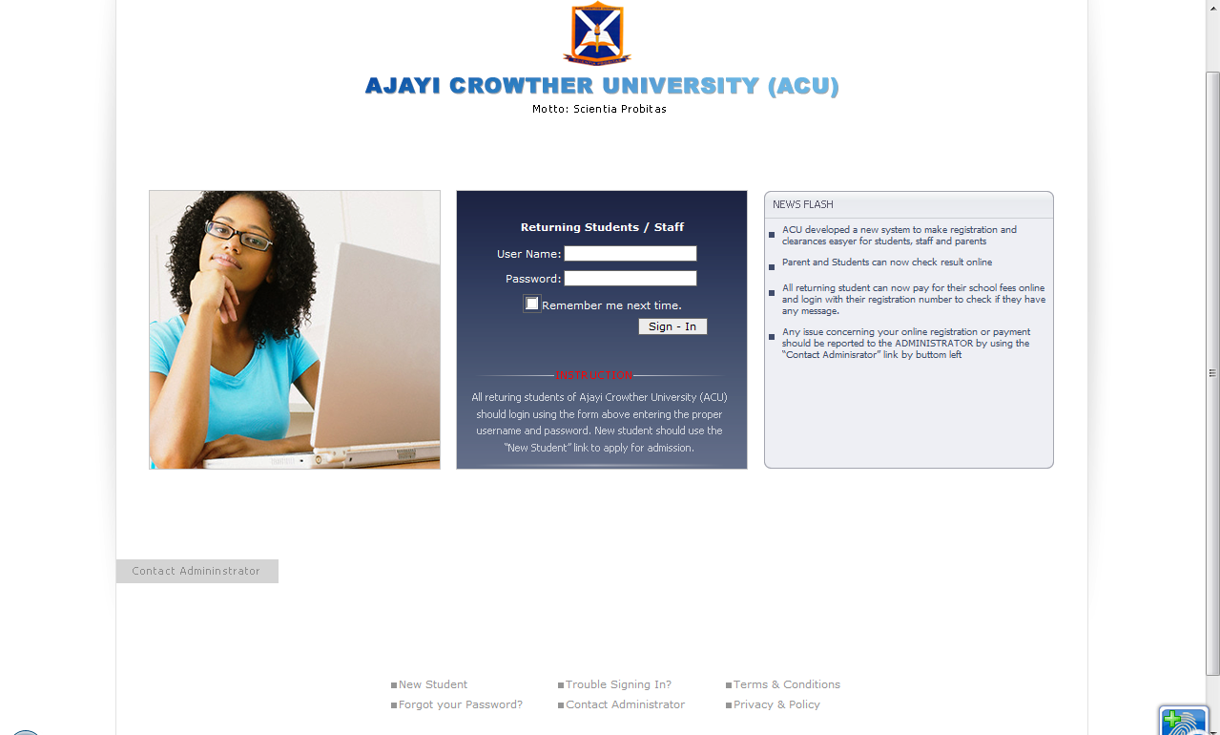

***Figure 1: shows the login screen for both staff / returning student, Figure 2: shows the scratch card interface for new registration***

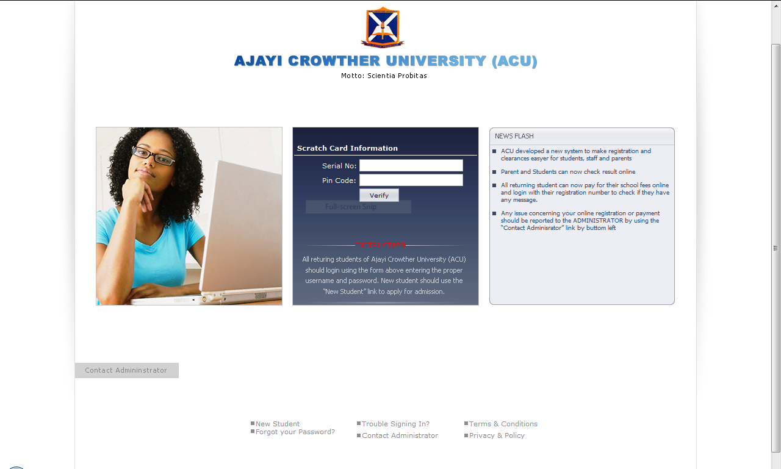

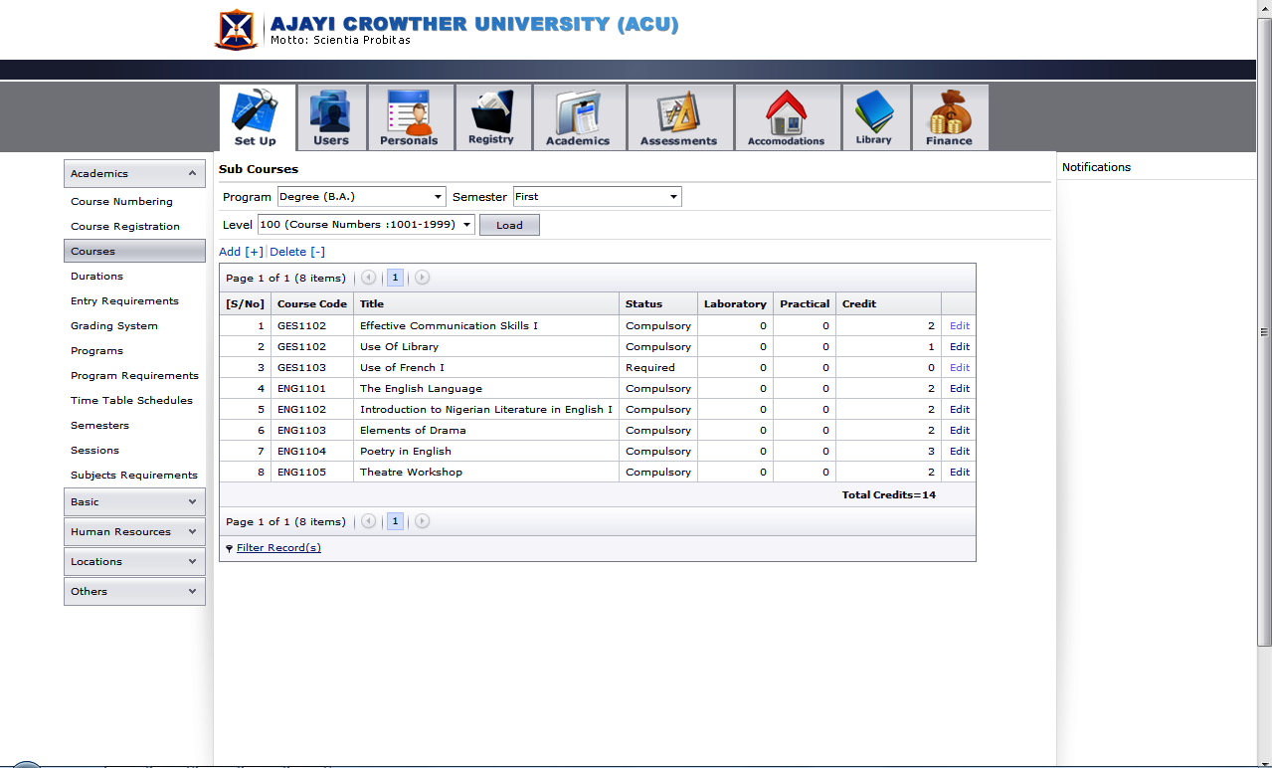

***Figure 3: shows the display view, Figure 4: Shows the editing mode***

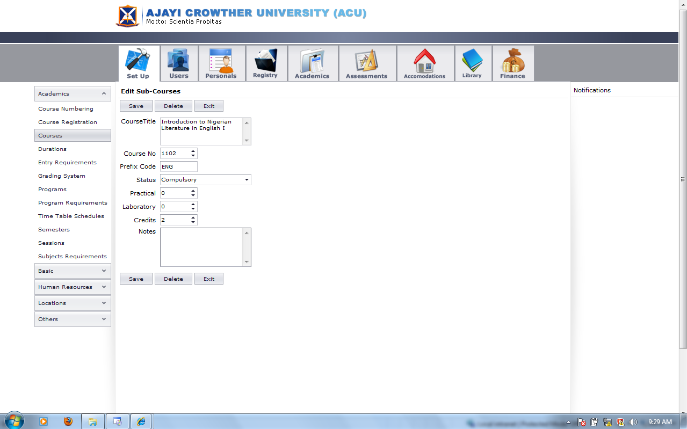

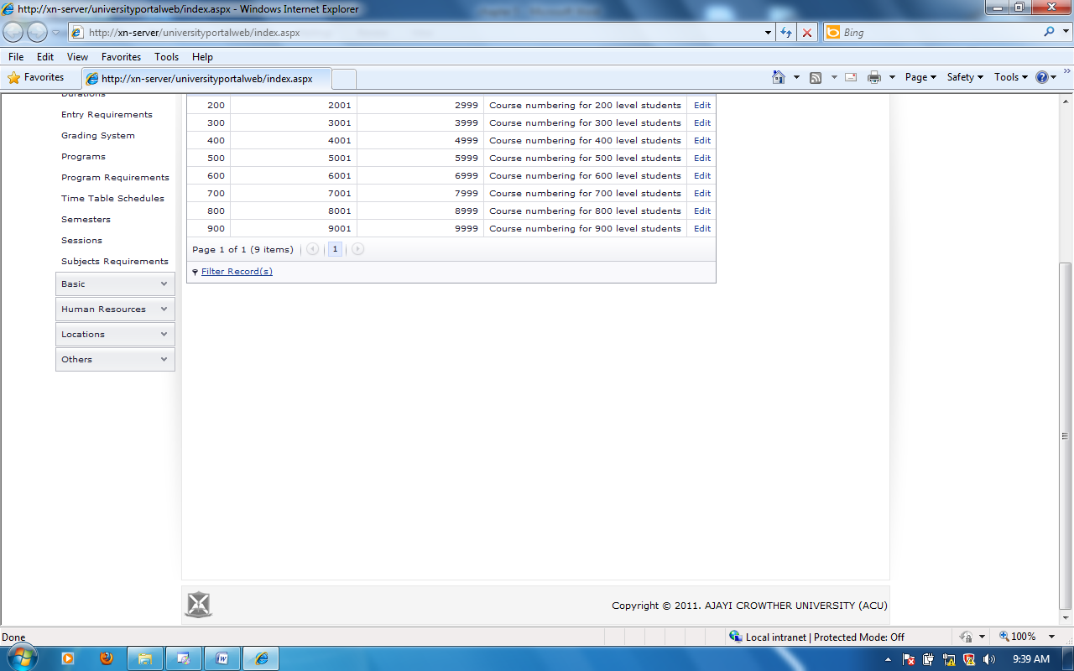

***Figure 5: shows the footer***

**Note:** Modules are available to users based on roles and permissions.

**5.5 Summary**

In this chapter we have outlined and discussed the techniques and processes which have been carried out to configure, install and set up the required development tools that would make the application run as expected. In doing this we have looked at the stages taken to meet the desired objectives